Course: MMDS

*Lab 01*

**Set up Hadoop**

***Fill answers of the questions below in the given tables.***

***Your screenshots must contain commands for required operations.***

## Question 1:

Set up Hadoop following this [tutorial](https://docs.google.com/document/d/11SAKiH05INO3tP91iUAuoqEnpSzS3Bg1AQfcCliD-jo/) and then take a screenshot of the hdfs-site ([localhost:9870](http://localhost:9870)) which shows information for NameNode Journal Status, NameNode Storage, DFS Storage Types (Overview page).

For example,

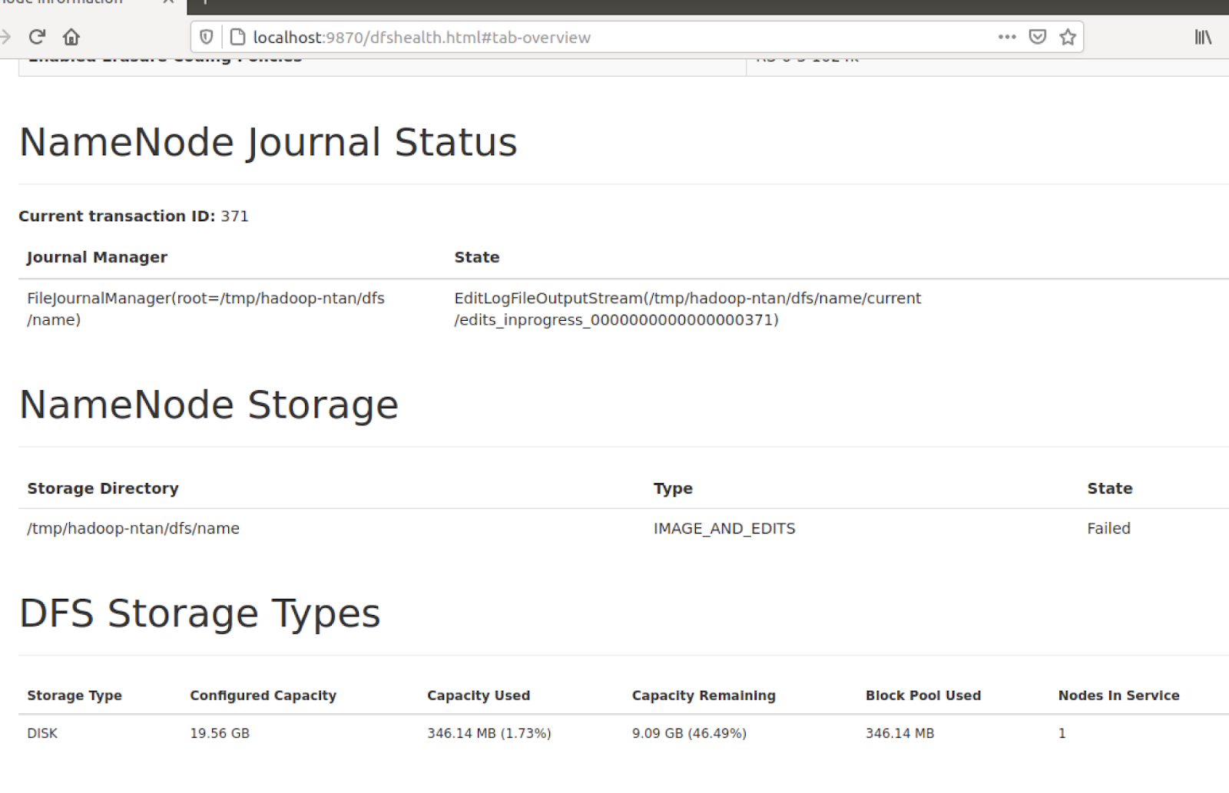

| *Your screenshot goes here* |
| --- |

## Question 2:

Set up Hadoop following this tutorial and then take a screenshot of the yarn-site ([localhost:8088](http://localhost:8088)) which shows information for nodes (<http://localhost:8088/cluster/nodes> ).

For example,

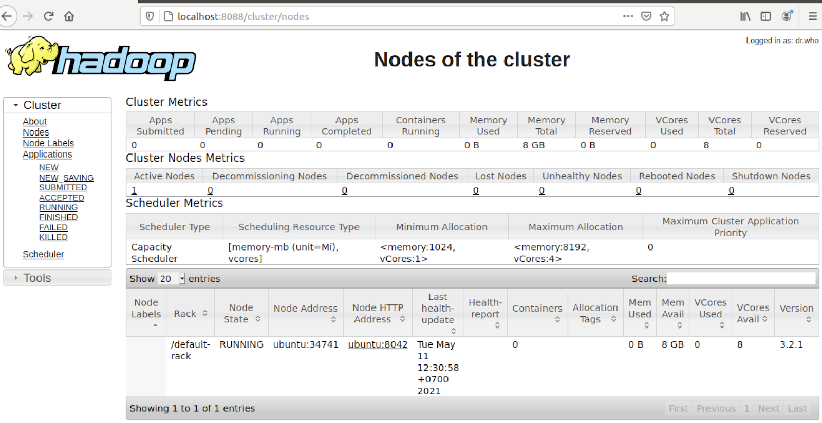

| *Your screenshot goes here* |
| --- |

## Submission Notice

* Export your answer file as pdf
* Rename the pdf following the format:

lab01_<student number>_<Full Name>.pdf

E.g: **lab01_123456_NguyenThanhAn.pdf**

*If you have not been assigned a student number yet, then use 123456 instead.*

* Careless mistakes in filename, format, question order, etc. are not accepted (0 pts).